Contents
Layout of the Web Site standard page. 1
Dashboard Screen 5
Create a Page 5
Modifying Page Content 9
Header Area 9
Menu Area 9
Slider Area 13
Create the Slider 13
Add the Slider to a page 18
Body Area 19
Widget Area 23
Footer Area 26
Events 28
Create an event manually 29
Maintain Events with Excel 32
Import Sample Files 34

Layout of the Web Site standard page.

The web site is maintained by maintaining elements on a standard page layout. You can create or modify a page using the elements. The standard web page layout is divided into the following sections:
Header Area
Menu Area
Slider Area
Body Area
Widget Area
Footer Area
Events

Click on the title to navigate to the explanation to maintain each of the areas or scroll down into this document.

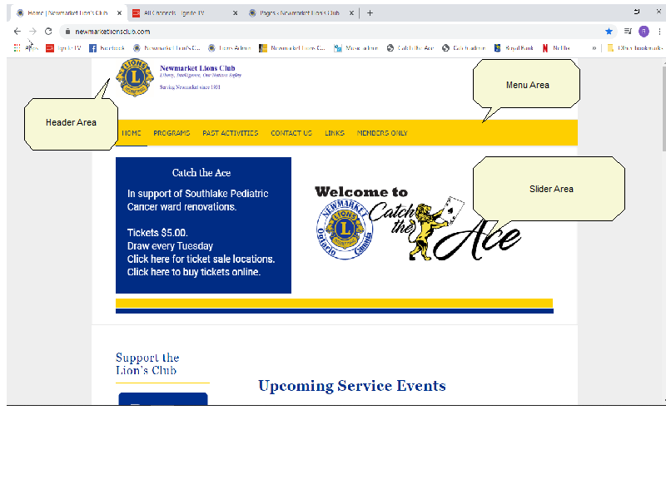

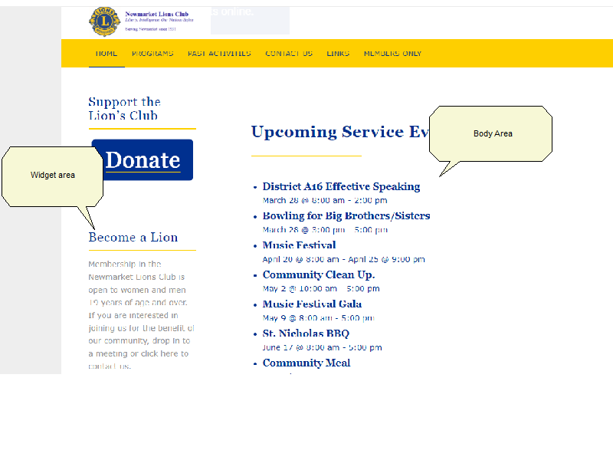
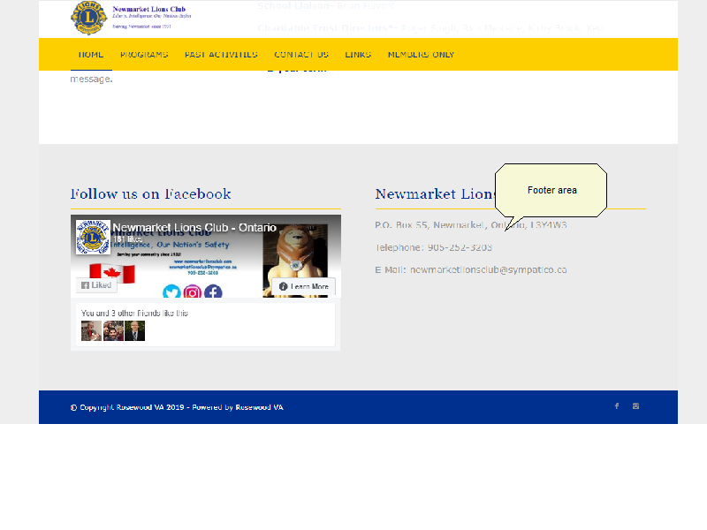

Dashboard Screen
When you log in to the Admin page of the Web Site, you will land on the Dashboard screen. This screen is the navigation menu to maintain all the various elements of a page. 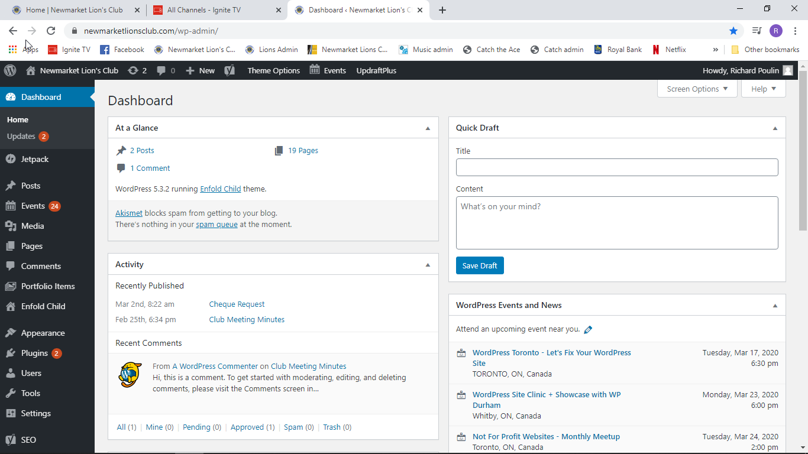

Create a Page

You create a page by using a template. Click on as shown below.
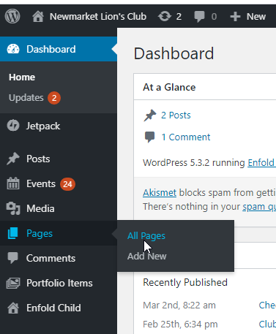

Click on Add new
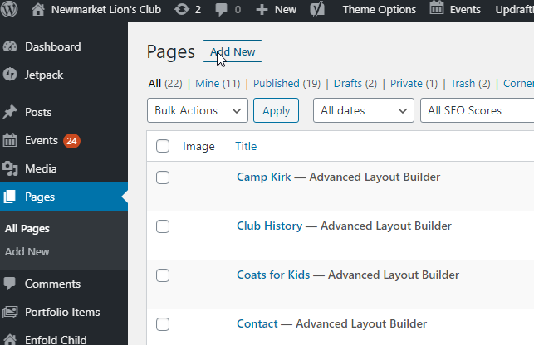

The following screen will Open. Click on Advanced Layout Editor. If the ICON displayed is Default Editor then you are already in the Advanced Layout Editor and you can proceed.

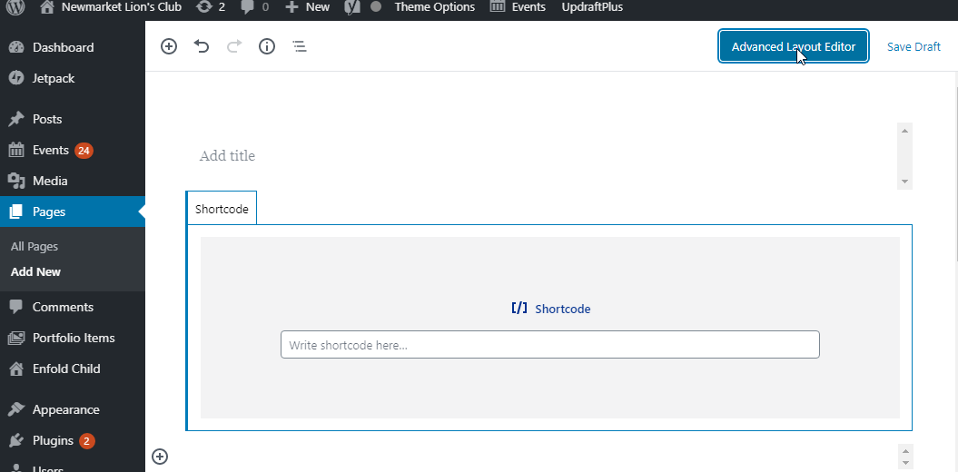

Enter the title of the page and then click on Template as shown below.
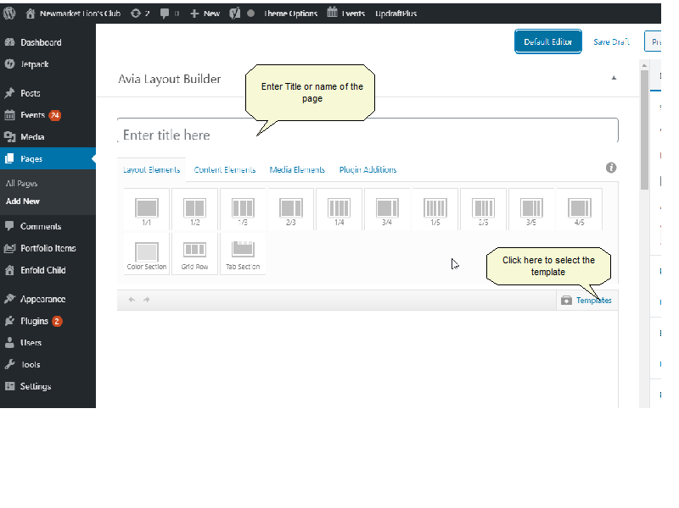
On the drop down that opens after clicking Template, select Homepage as shown below. The default layout will be opened. Modify the elements as required.

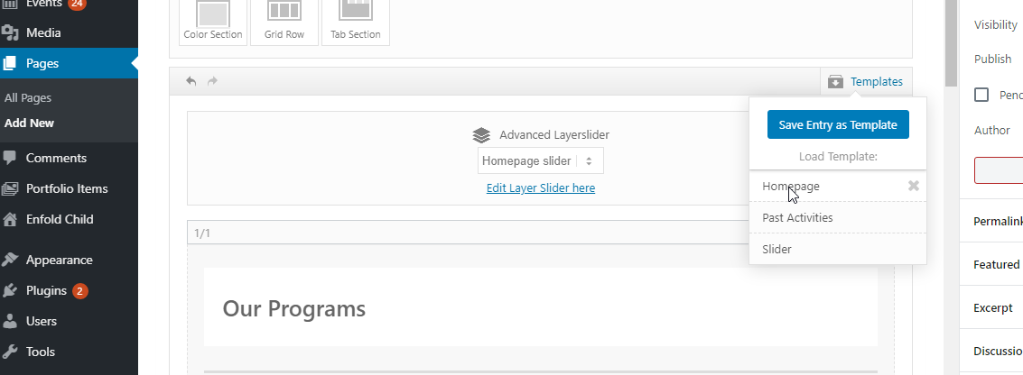

Modifying Page Content

Header Area

The header area can be modified using the Enfold Child option shown below.
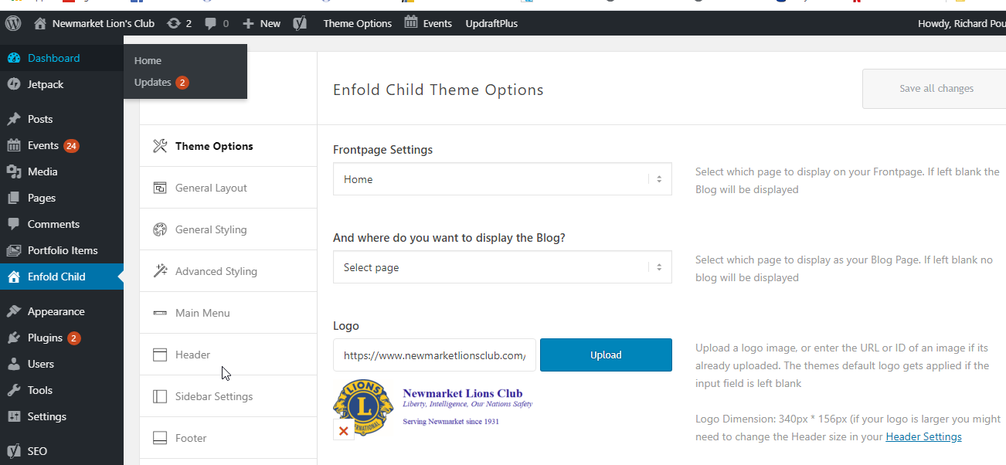
The logo can be modified by uploading a new image. Click on Upload to load the new file.

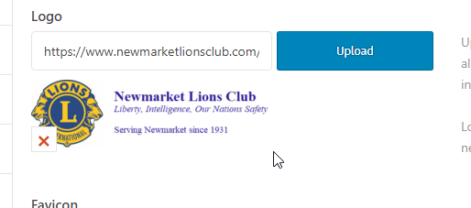

Menu Area

You can modify the Menu by selecting Appearance and then Menu from the Dashboard as shown below.
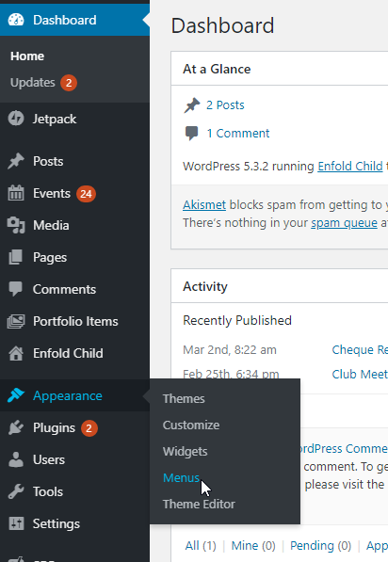

Pages, Posts, Events, etc can all be menu items. We will us a page as an example. From the Page list, select the page that you would like to see on the menu and click on Add to menu to create a new menu for the selected page.
For example, I have selected the Camp Kirk Page as shown below.
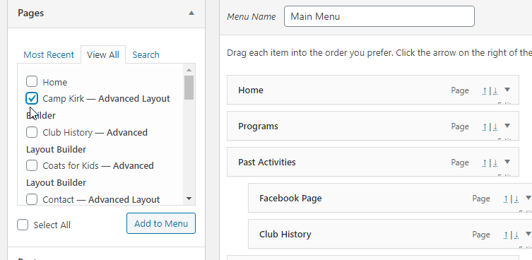
When I click on Add to Menu, the Camp Kirk Menu is shown.
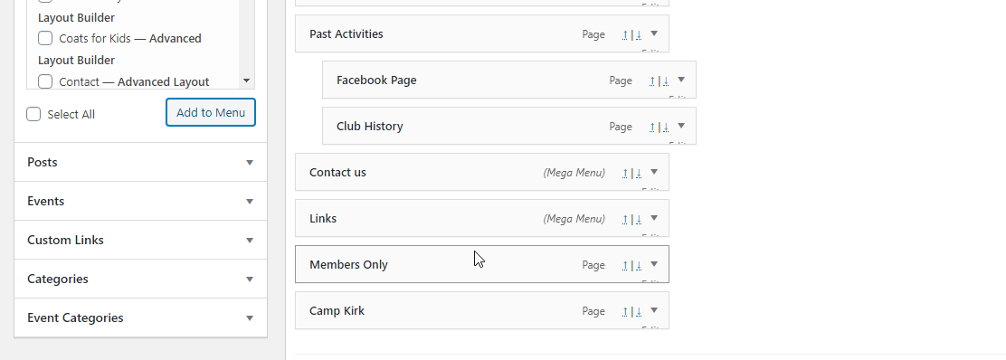

You can move the Menu by clicking and dragging the menu item under another menu item to create a Hierarchy as shown below.

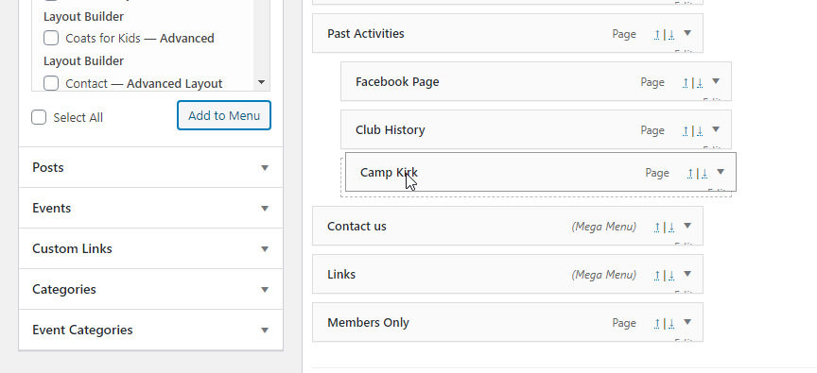
You can delete a menu by clicking on the down arrow on the right of the menu and then select Remove from the screen below.

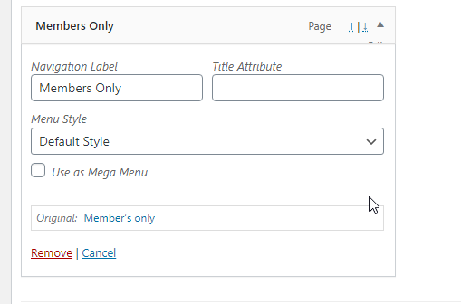

When done with your changes, Click on 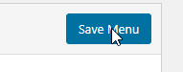.

Slider Area

Create the Slider
You need to create the Slider before you can place it on a page.
To create the Slider click on Slider Revolution as shown below.
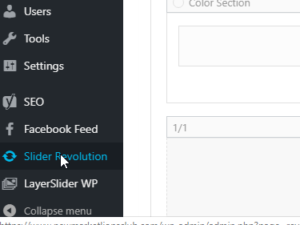
This will open the following screen. Scroll down on this screen
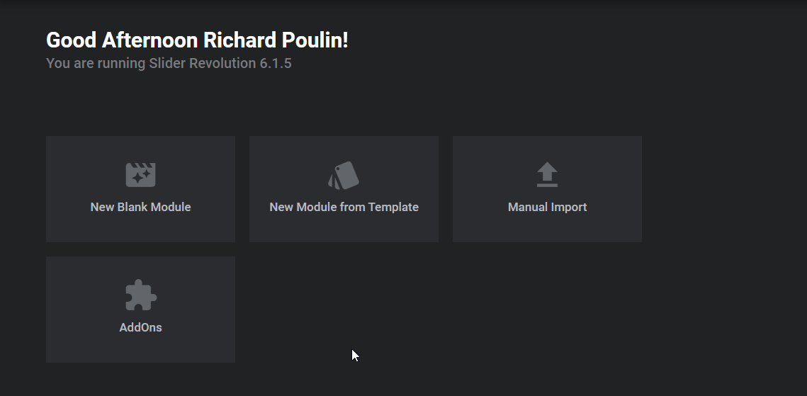
Scroll down on this screen to see the screen below.

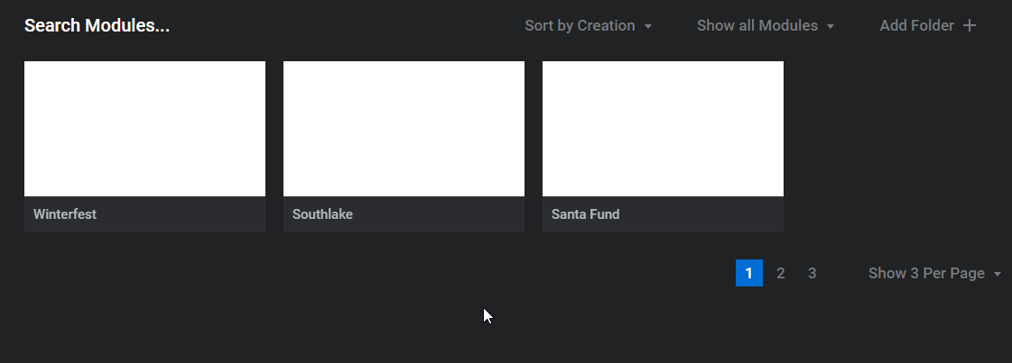
Here you can see all the sliders that are already created. You are seeing screen 1 of 3. I will use the Home Slider to show more info.

The Home Slider is on Screen 3.
Scroll over the Home Slider and click on the Pencil icon to edit.
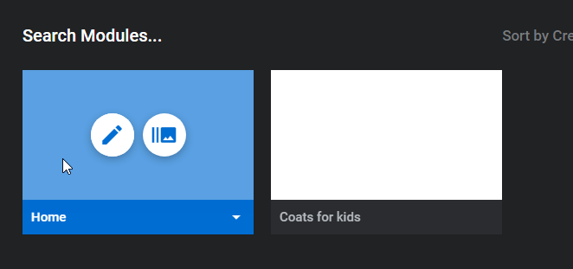
The edit screen will open
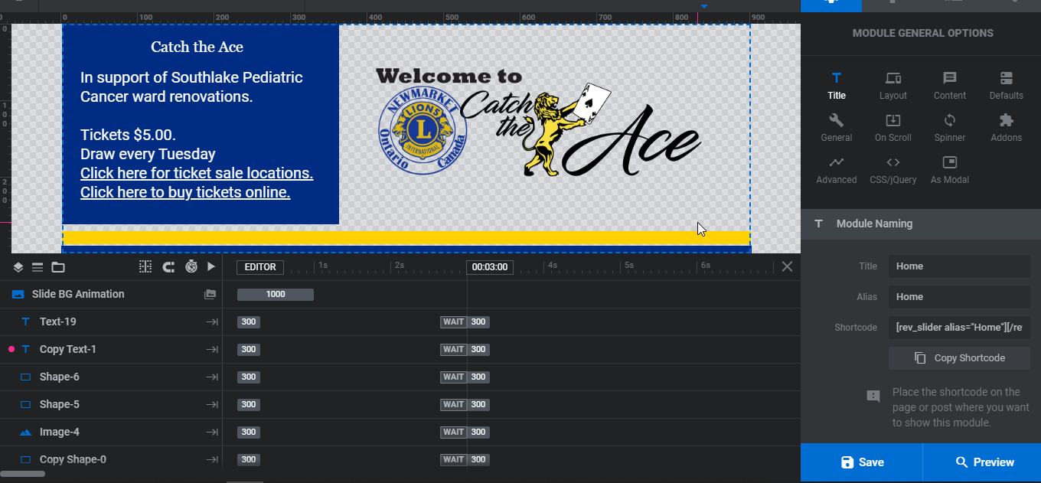
The Slider is composed of texts and shapes and images.
If you click on Text-19 for example you can modify the text as shown below.
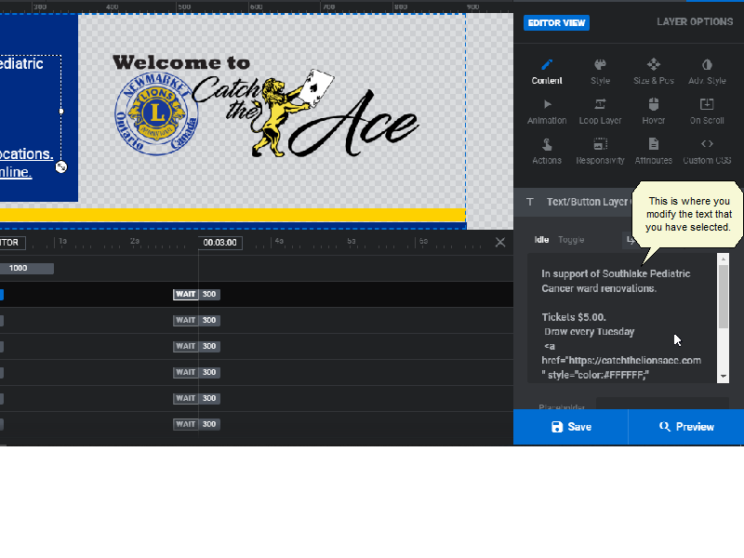
Click on Image 4 to display the image section to edit.
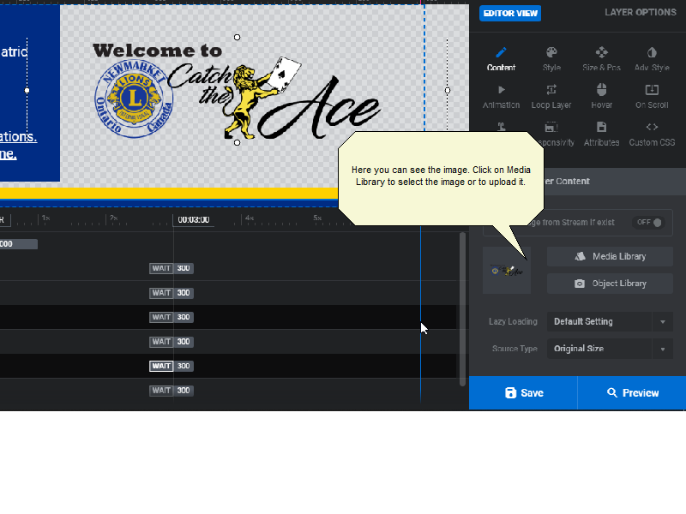
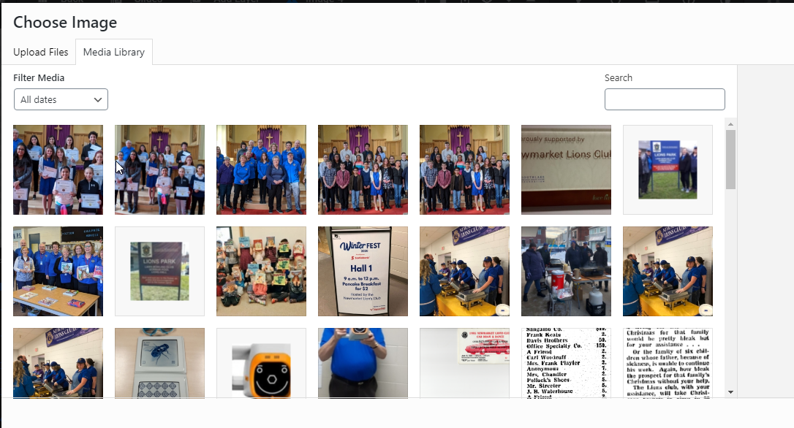

Click on Preview to view the slider or Save to save it.

You can have more than 1 slide on the slider. To create a new slide click on Slides.
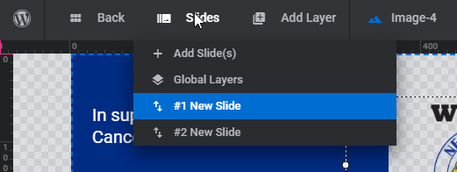
Then select a slide and click on duplicate.
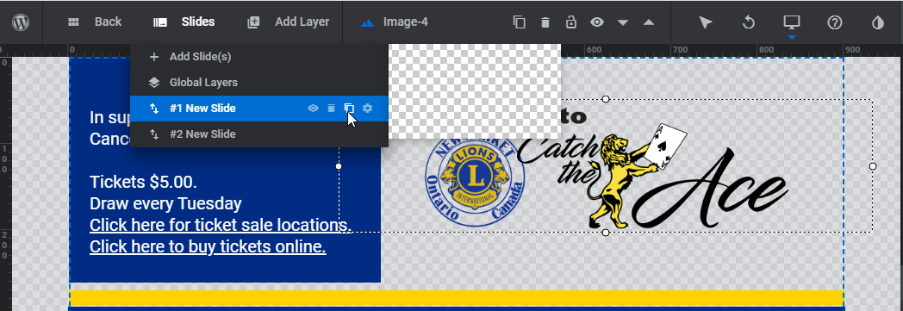
This will create a copy of the slide you have selected and you can then modify the texts and the images.

You can delete a slide by clicking on delete as shown below
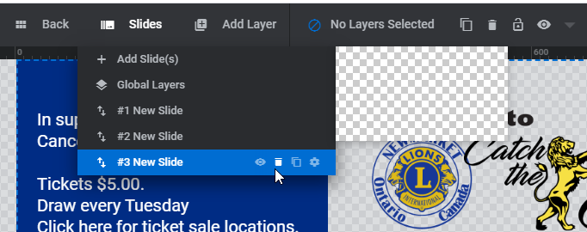
You can arrange the order of the slides by clicking on a slide and dragging it to the right order.

Add the Slider to a page

The Slider area is the first box on the page. It looks like the screen below.

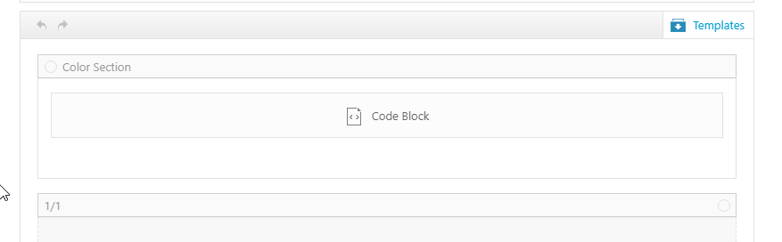
Click on the Code Block to open the screen below. Here you can type in the name of the slider you wish to show. Simply replace the word in Parenthesis in this case Home with the name of the slider you want to use.

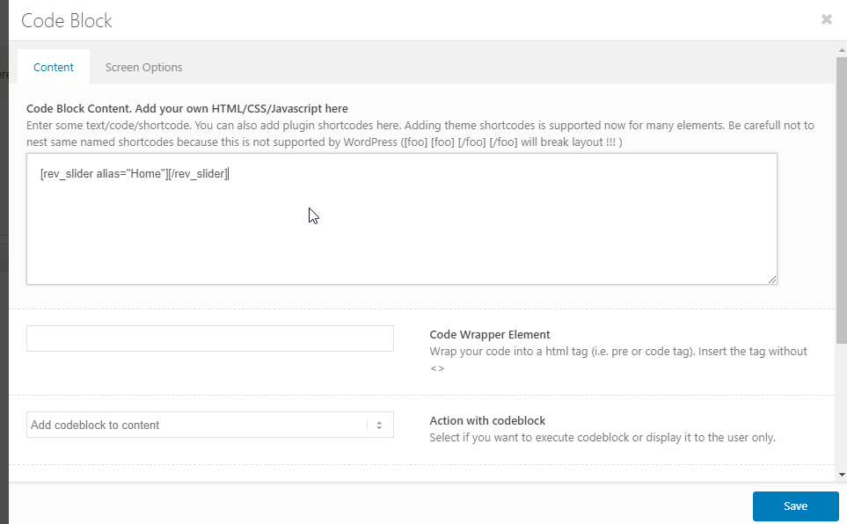

Body Area

The body of the page consists of Blocks. Blocks can be titles, text, images, etc.
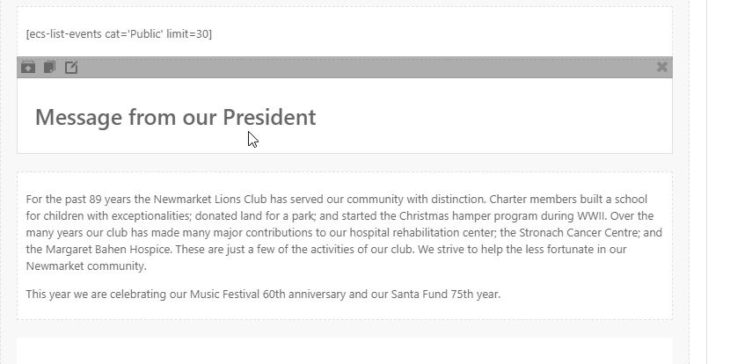
The screen above shows a Title block and a test block.

Click on a Title block to open the editor. Here you can modify the text for the title by replacing the text in the area highlighted below.
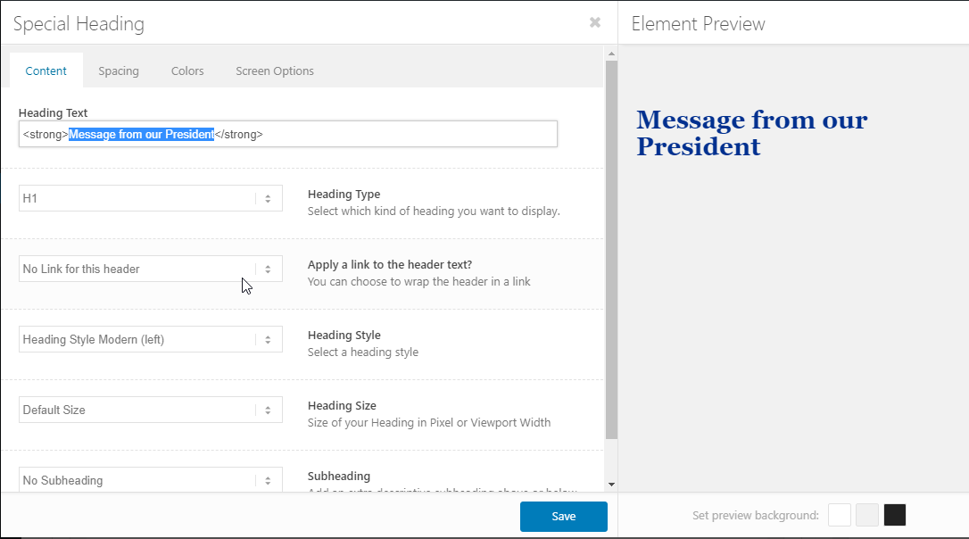

You can also change the Heading type by selecting it from the drop down.
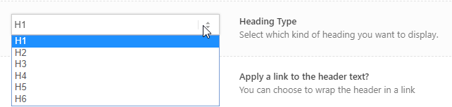

Click on save.

You can modify the text by clicking on the text to open the editor. You can also upload and include images in the text block by clicking on the Add Media icon.
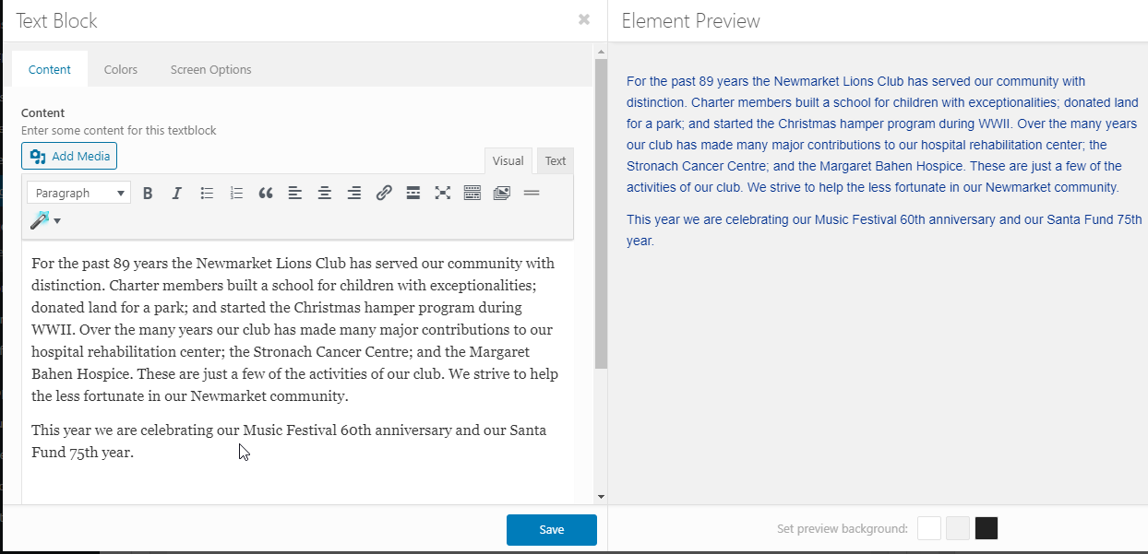

You can remove a block by clicking on the Red X next to the element.

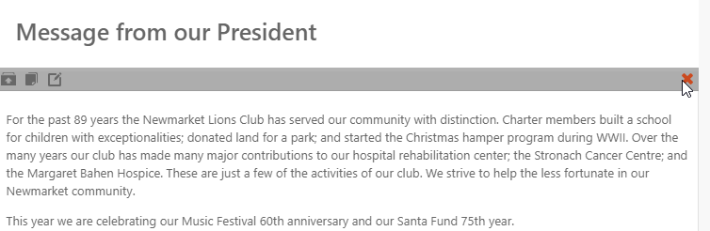
You can clone an element by clicking on the clone icon shown below.
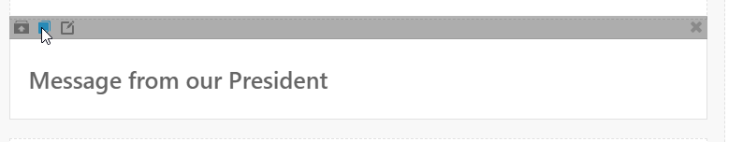

You can move elements by clicking and dragging in the page to rearrange them.

At the top of the page you can find additional layout, content and media elements that you can insert into the page. Content and media elements need to be inserted into a layout element.
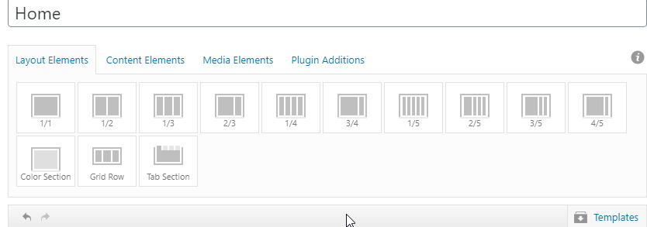
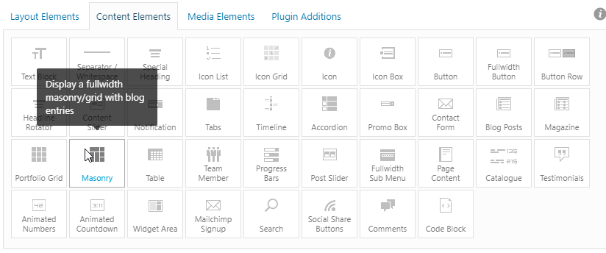
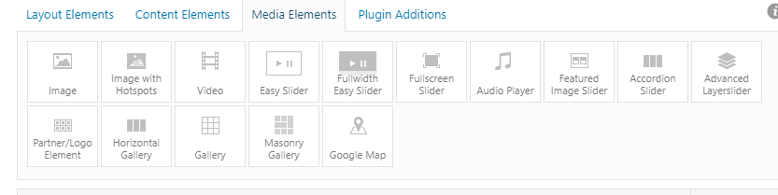

Once a page is created, you need to decide if it will a Public or Private page and finally you need to Publish or Update if it is already published. The screen below shows a page that is Public. The page is not yet published which means that it is not visible yet. Once Published, the Publish Icon changes to Update.

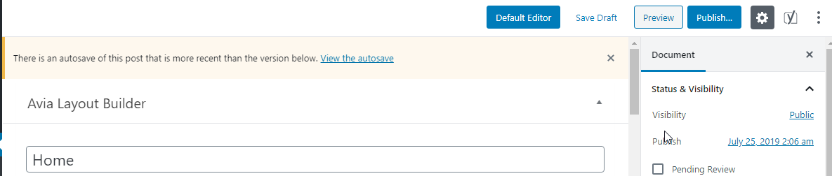

Widget Area

The widget area contains the boiler plate texts the appear on every page such as

The widgets can be modified by selecting Appearance – Widgets from the Dashboard as shown below.
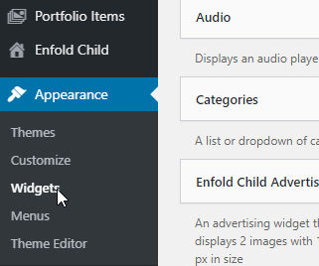

This will display the following screen
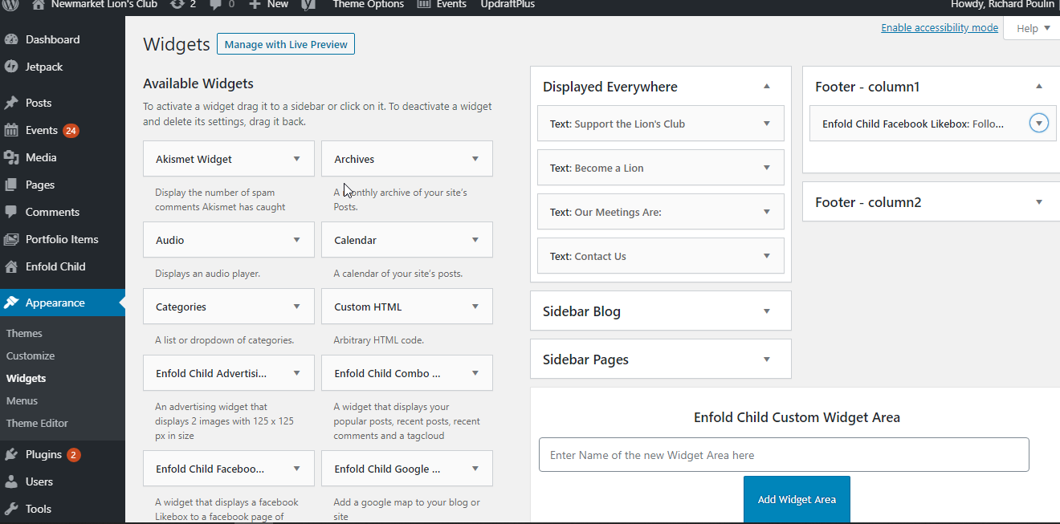

You can then edit the various widgets shown below by clicking on the down arrow at the end of the widget.

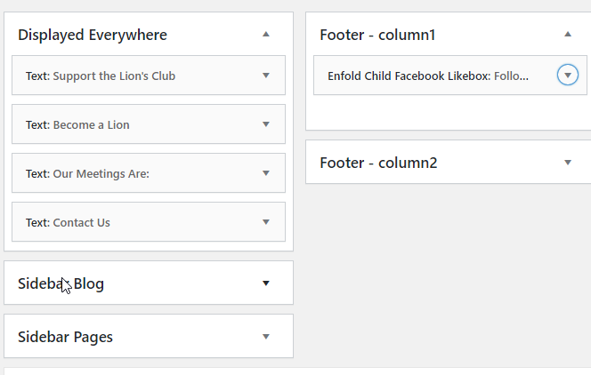
Here you can modify the text and add media.

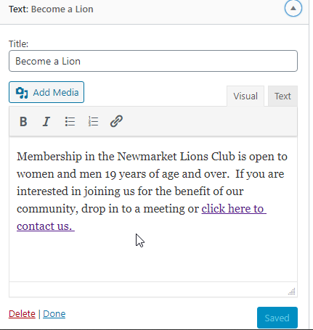

Footer Area

The footer area can also be modified using the Widgets.
Select the footer to modify by clicking on the down arrow on the right of the title.

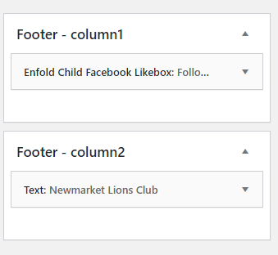

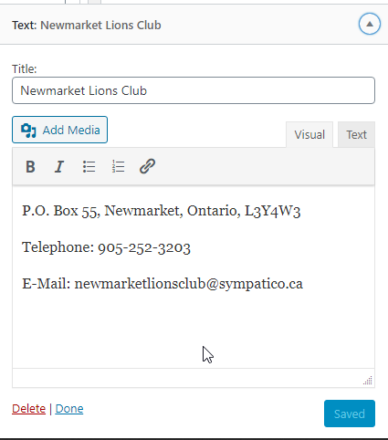

Events

Events can be created individually or by importing from an Excel Spreadsheet. Events can be assigned categories Public or Private for example.

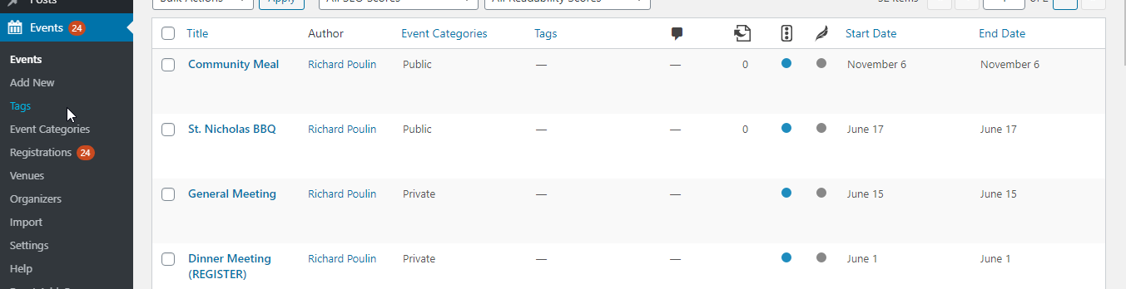

Create an event manually

To create an event manually click on Events and the Add new from the Dashboard as shown below.
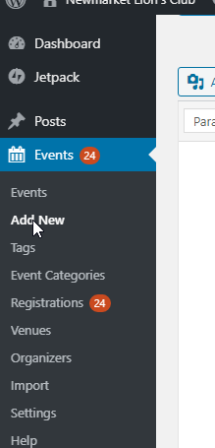
Type a Title and a description of the event. You can insert pictures as well.
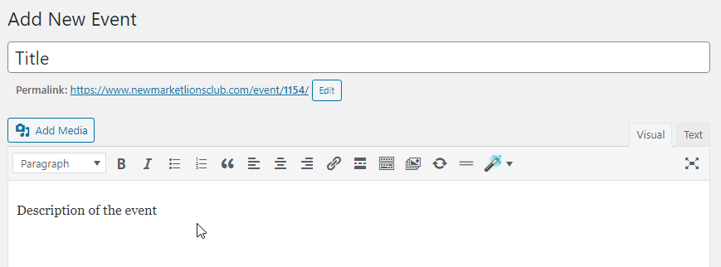
Fill in the start time and date and the end time.
Fill in the Location. You can create Venue and reuse them. You can maintain Google maps for the venues.
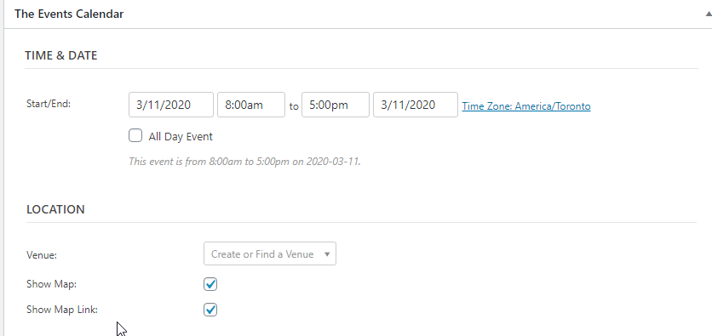
You can maintain an organizer, costs, and specify if registration is required.
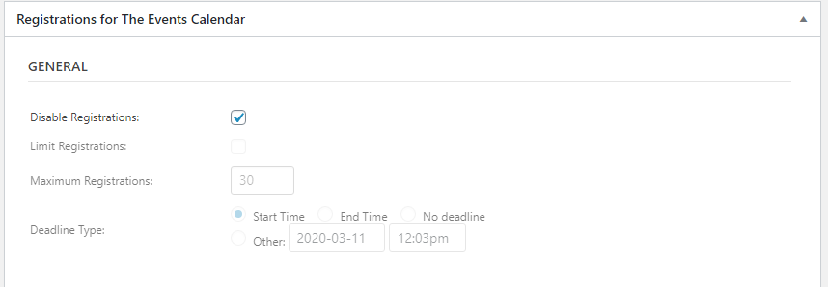

You can specify a category on the right of the screen and Publish the event as shown below.
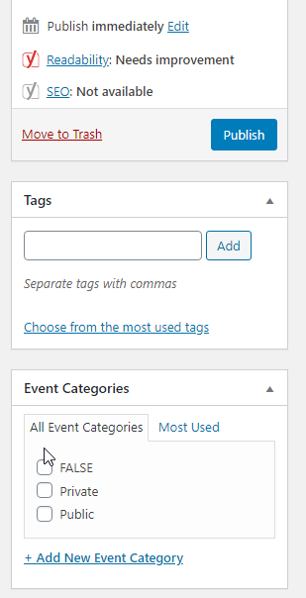

Maintain Events with Excel

You can use Events, Import from the dashboard to import events from Excel.
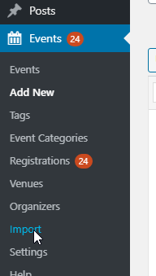

From the Events Import screen select Import Origin from CSV as shown below. Press enter. Select Events for Content type. Press enter. Select Upload
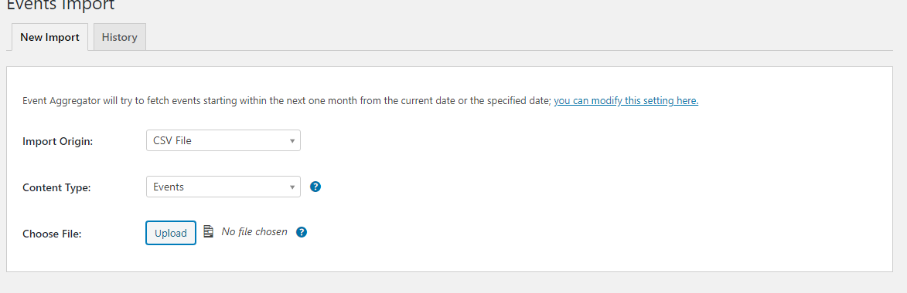
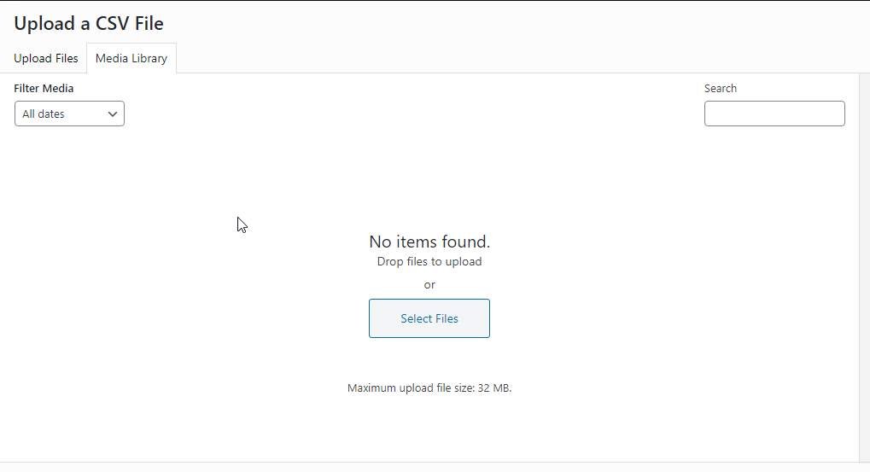

Click on Upload Files Tab on top of the page.
Once your file is uploaded, click on Select as shown below.
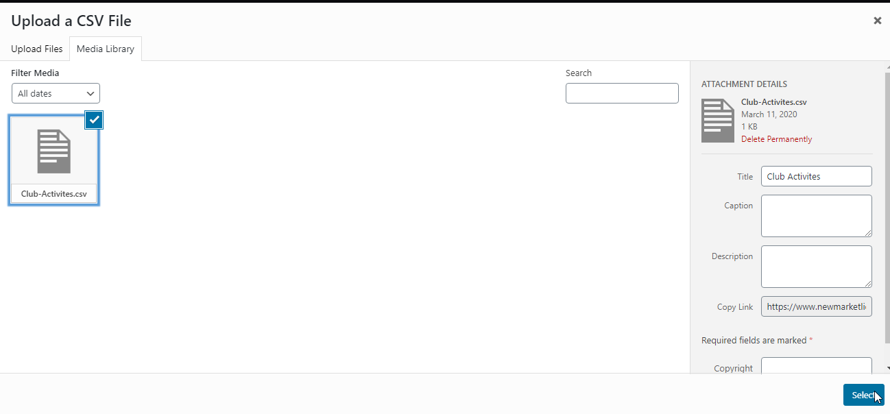

Then click on preview as shown below.
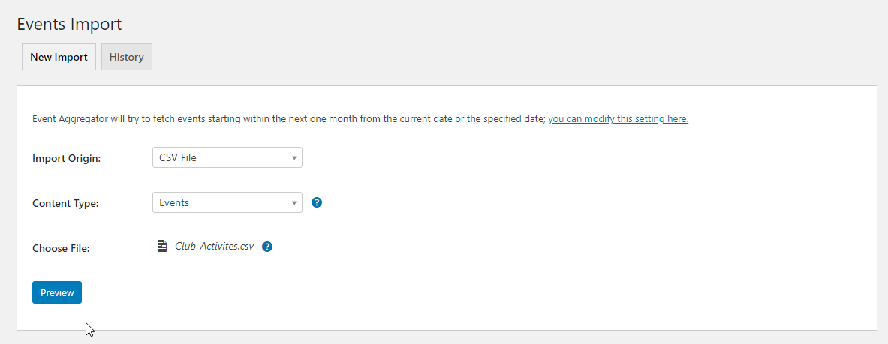
If satisfied with the preview Click on Import all as shown below.
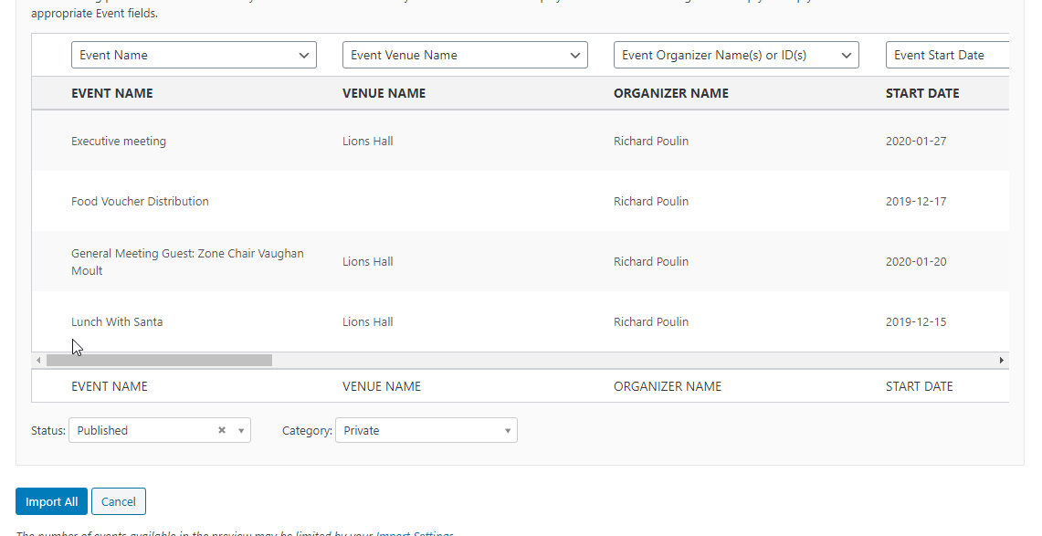

Import Sample Files

The Club Activities file is set up for Public events. The Club Meetings file is set up for Private events.

The registration requirement is set by default for events. It is necessary to ensure the default is set correctly prior to importing events. To disable or enable registrations by default go to Events – Registrations. Select the Form Tab, Make the appropriate selection for Disable Registrations by default as shown below.

